Some of our Models

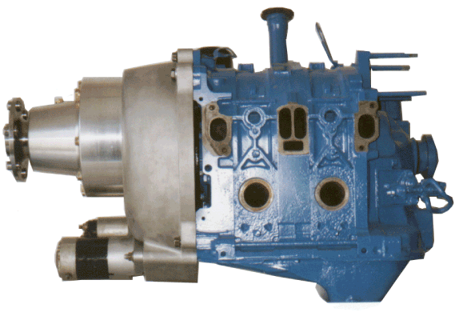

Mazda Rotary
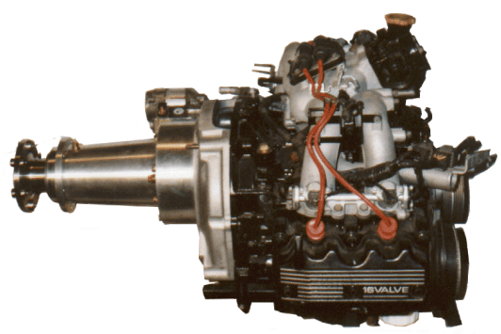

Subaru
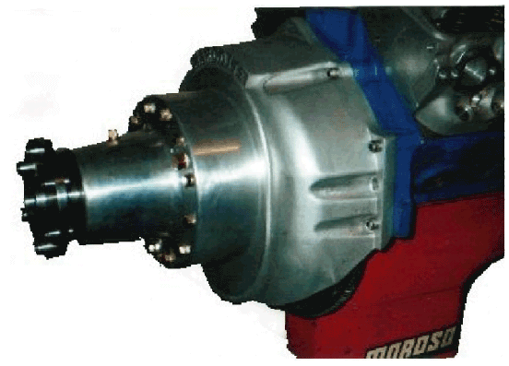

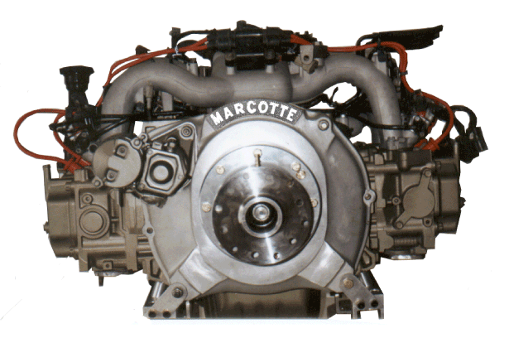

V-8

YOUR DIRECT CONTACT WITH MANUFACTURER

MOTEUR AVANCE MEGA INC.

TO ORDER OR FOR TECHNICAL SUPPORT

Guy Marcotte
217, rang Sud
Ste-Geneviève-de-Batiscan
(Québec) G0X 2R0
Canada

Tel: (418) 362-2569
Fax: (418) 362-2460
E-Mail: megapropulsion@netscape.net

Ray Fiset
1-888-871-3761
Fax: (418) 877-3408
E-Mail: rayfiset@globetrotter.net

The Widest Line of
Engines and
Gearboxes
for all Kinds of
Recreational Aircrafts



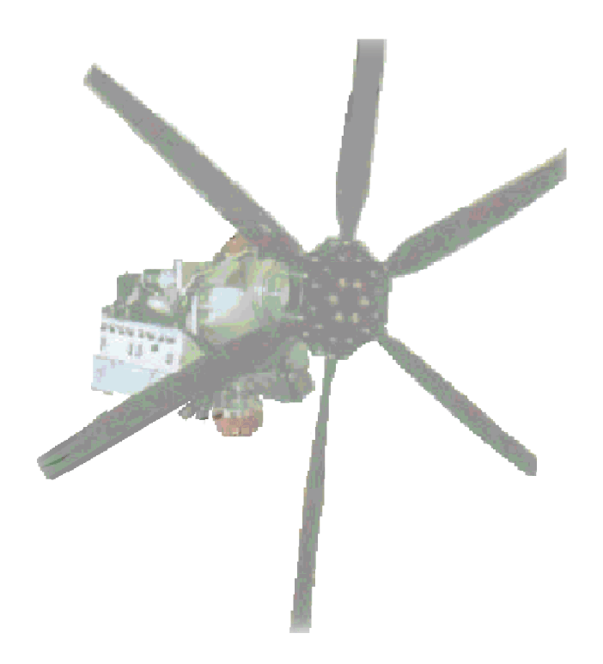
GUY MARCOTTE
Designer
Manufacturer

V8 aéro engines 250 to 600 H.P
Subaru 75 to 250 H.P.
Propeller speed reduction units 100 to 600 H.P.
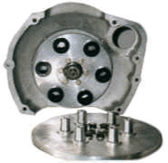

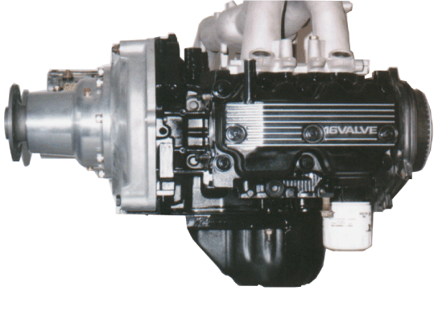

DAMPER The unique 6061T-6 aluminum coupling system provides efficient torsional vibration canceling with its elastomeric insert and assure a constant drive whatever occurs. It can easily handle up to 7 000 rpm which could be appreciated when using a hi-performance engine.

VARIABLE PITCH Models 200-300-450 have hydraulic variable pitch configuration as standard feature. Electrical variable pitch propellers can be installed on all models including models 100-150.

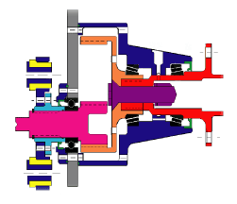

MODELS | Max.  H.P. | Max.  Torque | AVAILABLE RATIOS
M-100 | 100 | 150 | 2.04:1
M-150 | 150 | 200 | 1.64:1 | 1.75:1 | 1.88:1 | 2.04:1
M-200-VP | 200 | 250 | 1.77:1 | 1.89:1 | 2.03:1 | 2.20:1
M-300-VP | 300 | 350 | 1.81:1 | 1.93:1 | 2.06:1 | 2.20:1 | 2.40:1
M-450-VP | 450 | 500 | 1.84:1 | 1.75:1 | 1.88:1 | 2.04:1
M-450-VPD | 450 | 500 | DIRECT DRIVE
TO FIND THE CLOSEST RATIO NEEDED: (MAX.ENG.RPM.)÷ BY PROP. RPM. = RATIO

300VP Model
drawn by Guy MARCOTTE
October 4th 1998

DIRECT BOLT-ON MARCOTTE’S gearboxes fit any alternative engine with use of an adapter plate or, much better, a 3555-T6 aluminum cast direct bolt-on bell-housing. We provide bell-housings for all Subaru engines, Mazda Rotary and also for Chevy Ford and Chrysler V-8 bolt pattern. It takes only half an hour to install such a unit on your engine.

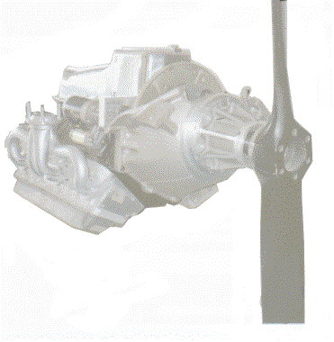

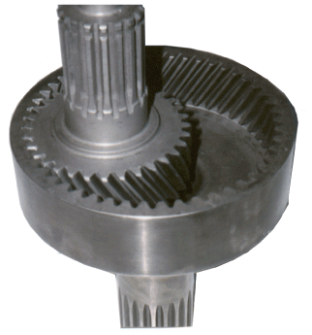

GEARS Unique helical gears with 30º helix are CNC machined from 4340 certified steel billet, and teeth hardened to 62Rc. before we assembly it in the 6061-T6 aluminum propeller-shaft housing with maximum load conical bearings and dual lips seals for maximal reliability.

HELICOPTERS Easily adaptable to drive-shafts, chains or straps, these units can also be used as primary transmission to slow down the engine’s output rpm, before entering any other transfer-case, reducing by the way its loss of power and vibration as well as improving its reliability and toughness.

