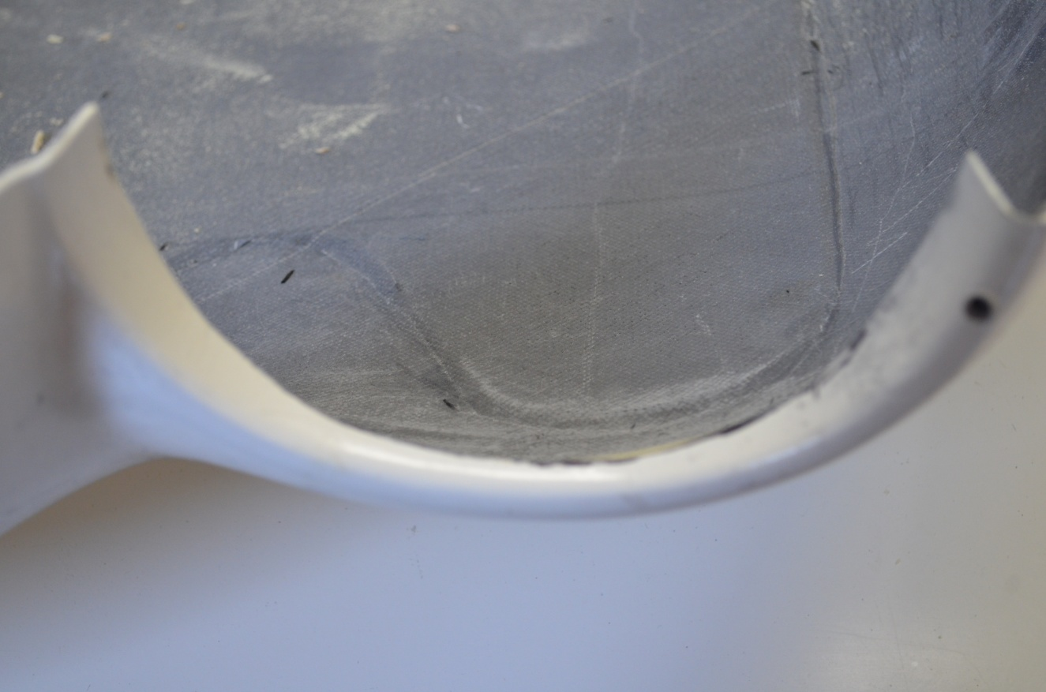

Exaggerated drawing of area to remove

¼- 5/16” from edge of inner lip to height of contour.

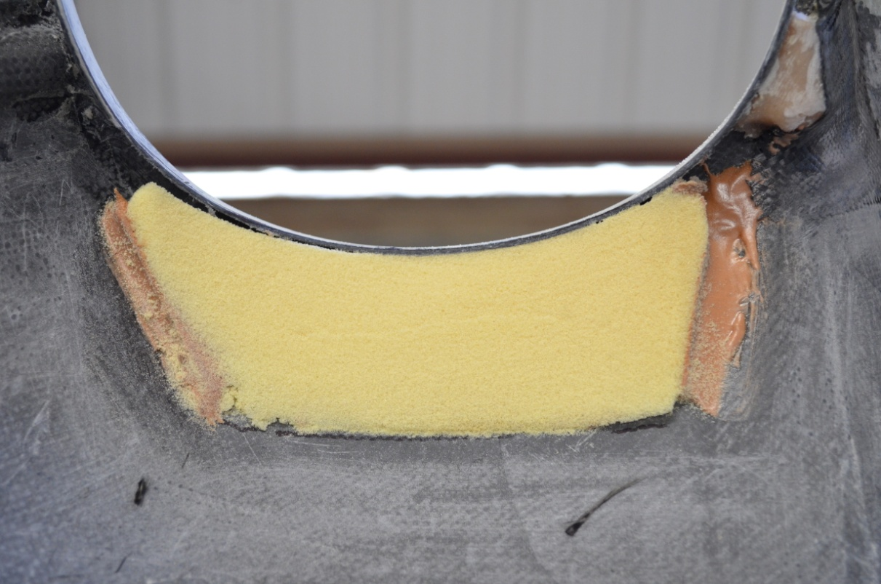

Clark foam bonded in and sanded to create contour for 2 bid graphite layup to create laminar flow shape.