Still More on Lift

Saying that "Lift occurs because flow is turned downward creating downwash." is like saying that milk comes from cartons. While technically correct, it doesn't tell the complete story of how the milk got into the carton.
Brent Regan

I love the way Brent cuts to the core of the question. Reynolds, Von Karman, Prandtl and other bright fellows scratched their heads a long, long time on this question, and you can get philosophical about cause and effect (which came first, the higher velocity or the lower pressure?). It is all a bit confusing and difficult to visualize.

Let’s try a mental experiment to see if we can gain some more understanding. I apologize for the hand drawn figure, but I failed to find a famous flim clip by Prandtl (I think) we were shown in grad school. It shows a wing section in a stationary water tank with dust on the surface water, and the wing sticking up out of the water. The wing section is then accelerated from a stop and the resulting flow field becomes visible because of the reflective dust that makes streaks on the film image. Below is my attempt at recreating this figure.

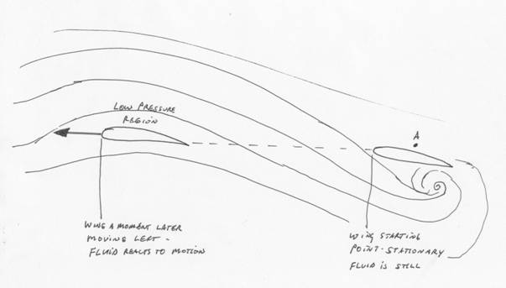

For this experiment, first imagine the wing stationary (as shown on the right) in a stationary body of fluid. Then imagine accelerating the wing to the left so that at the position shown at the left the wing is moving away from its starting point. (Think aircraft carrier cat shot.) The flow field (curved lines) are a snap shot showing the distortion of the fluid mass that results from the moving wing at the left.

When the wing first starts moving, imagine you are at an element of fluid at point A. As the wing moves away, the nearby surface moves down creating a low pressure region. The fluid from farther above, being at higher pressure, rushes into the fill the low pressure area, but as it does so, the wing moves away. As the wing leaves its starting position, there is a momentary down flow where the wing was, and a “starting vortex” is created that is parallel to the wing span.

(For the puritans among us, this vortex bends toward the receding wing at the wing tips and becomes parallel to the motion of the wing that is, counter rotating wingtip vortices. The whole vortex structure takes on the shape of a horse shoe, but dissipates quickly due to friction. The wing tip vortices continue to be generated as lift continues to be created. But I digress.)

So one could say that lift is generated because a solid surface moves away from the fluid creating a low pressure in the fluid above the surface. Higher pressure fluid rushes into the low pressure area driven by the pressure difference.

Imagine being at point A again, a piece of fluid (a gnat floating in the air, if you will) when the wing moves by slightly below you. The first thing you sense is the pressure falling above you as the low pressure area above the wing extends forward of the wing. You are “sucked” up by the upwash in front of the leading edge (higher pressure area moving to the lower pressure region). Then you stop rising as the wing passes beneath you, and the top surface if the wing which first pushed you up now recedes below you creating a low pressure area as the flow tries to follow the moving wing. The higher pressure farther above the wing flows into the low pressure region immediately above the wing, and your tiny gnat body is then carried downward in the downwash. As the wing moves away, you are left in a big downdraft between the two counter rotating wing time vortices.

The gnat feels a push up followed by a BIG push down.

If your gnat body was near a wing tip when the wing went by, then in addition to being blown down (“sucked down” if you prefer) you get pushed to one side and proceed to get wrapped up in the wing tip vortex. It is a very bad day for you indeed. Bring a barf bag.

So one answer to “where does lift come from” is “Lift (from above the wing) comes from the low pressure area created above the wing because the wing top surface rushes away from the flow, and the flow attempts to follow, ending up with a downward motion.” (How’s THAT, Brent!)

Lift from below the wing comes from the wing mashing the flow down and out of the way creating a comparatively high pressure area. The sum of the two, top and bottom forces, yields the final lift.

Note in all of this that Bernoulli is satisfied. Where there is curvature in the flow, low pressure occurs (creating a higher velocity) toward the center of the curvature (across the top surface of the wing.) If you like, the centripedal forces “fling the flow outward” creating a low pressure area along the top wing surface.

The low pressure creates the differential pressure (compared to ambient) that forces the flow to accelerate. Conservation of energy means that since the static pressure falls, the dynamic pressure (from velocity) must increase to keep the total pressure (static plus dynamic) constant.

Newton is also satisfied. Lift is equal to the change in vertical momentum of the mass flow passing over the wing. How much mass flow is this? Well, the flow field theoretically extends to infinity, but if you integrate from minus infinity way off to the left to plus infinity all the way to the right, you find that the mass flow deflected downward (in pounds of mass per second) is very roughly equal to the mass flow that passes through a tube having diameter equal to the wing span of the airplane.

Very convenient.

Imagine a Lancair IV at 3000 pounds weight (lift) and 200 KTAS with 30 foot wing span (span loading of 100 pounds per foot of wing span). The mass flow deflected is equal to 200 KTAS times the area of a 30 foot diameter circle times the density of air. Assuming sea level, air density = 0.078 lbs/cubic foot standard day, and remembering conversion factors and the gravitational constant of 32.2 ft lbs force /lbs mass second squared, my calculator shows that the airplane is “intercepting and deflecting” a flow of about 18, 600 pounds per second of air, and the average downwash will be 5.2 feet per second, or a bit over 3 miles an hour. Viewed another way, at 200 KTAS sea level, the angle of the attack is very, very small so the downwash is small. Go, slower, increase angle of attack and downwash increases. Approach at 100 KTAS and the downwash doubles to about 10 MPH. Yawn.

Let’s take that 747 passing low over the beach for landing (neglecting ground effect which plays a big part when close to the surface). A 747-400 has a 212 foot wingspan, a gross weight of 800-870,000 pounds (span loading of 3800 pounds per foot of wingspan at take off), and a fuel capacity of about 376,000 pounds.

Given that the airport in question must have a short runway, let’s assume tanks nearly empty and less than full load in pax/baggage, use 400,000 pounds for landing (span loading of about 1890 pounds per foot of wingspan) and an approach speed of 140 knots (typical Vref at 40 degrees flaps). My calculator yields an “intercepted flow” of 69,700 pounds per second and an average downwash of 200 feet per second (about 140 miles per hour) which is why the separation standard between heavies and everyone else is as large as it is. The wing flaps are deflected down 40 degrees and the total downwash angle is probably more like 45 degrees, so this makes sense. It also says that those on the beach will get some sand blasting as shown in some of the photographs, but all of this will be substantially reduced by ground effect.

One can study flow visualization pictures for a long time, and the more you look, the more you see, and then the more questions you have to ask. For a beautiful set of flow visualization photos see the PDF document at the Von Karman Institute:

http://chaos.usc.es/FMMETEO/CLASES/Web_Fluidos/flow_visualizations.pdf

Caution: some of the visualizations are not of 2 D flow around a section, but actually visualization of the flow along the wall where a section intersects the wall. This is highly complex 3D flow, and the analogy is the flow on our aircraft between wing and fuselage at higher angles of attack. At low angles of attack (cruise for us) the flow is well ordered. At high angles of attack, particularly approaching stall, the 3D flow at the intersection gets complicated as the picture of the turbine blade cascade and wall illustrates.

I think this picture is particularly beautiful.

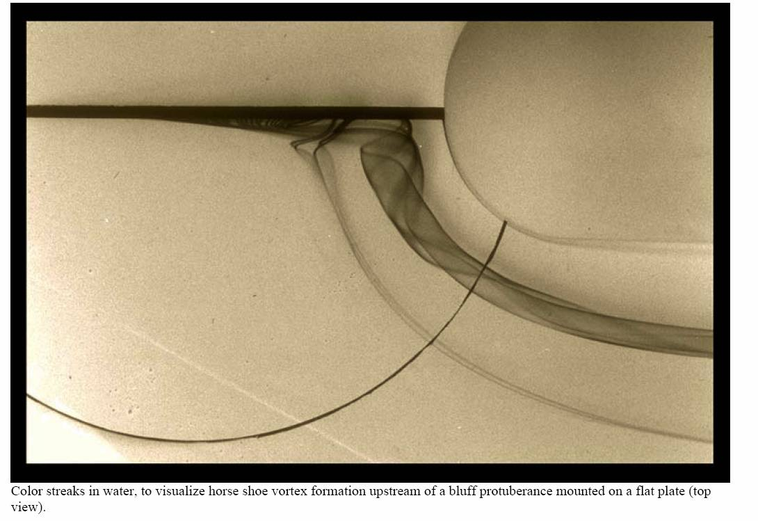

Flow from the left. Think wing intersecting fuselage when you study this picture with no fairing at the intersection. Here boundary layer flow (slow) moves along the wall toward the bluff body while faster free stream flow hits the bluff body farther from the wall, and having more momentum, spreads down the leading edge toward the wall displacing the boundary layer. The more energetic flow then flows forward along the wall (opposite to the free stream direction) until it loses momentum, then rolls up into a vortex. (The PDF document has another figure of this experiment, side view.)

One can see a portion of this phenomenon when flying a high wing Cessna in the rain, and studying the water flow around the wing/windshield interface. Droplets clearly move from the wing leading edge forward a short distance before being turned downstream.

I am easily entertained.

But I digress yet again.

Fred

