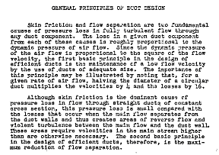
Causes of Pressure Loss
. Skin Friction
. Flow Separation

Flow Separation is by far the worst of the two

Keep Flow Velocity Sufficiently High to avoid boundary Layer separation

Causes of Flow Separation

. Excessively Sharp Bends
. Adverse Pressure Gradient

Higher Velocity than desirable from skin friction viewpoint may be necessary to prevent flow separation

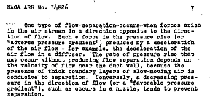

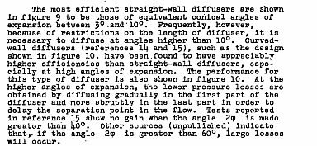
Curved Wall Diffuser much more efficient in pressure recover than straight wall

. Keep Velocity high through most of duct
. Expand Rapidly near core for Pressure Recovery

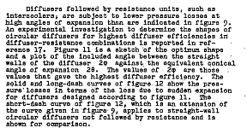
Heat Exchanger Core aids in efficient Pressure Recovery

. Both Diffuser Walls and Core contribute to effective Pressure Recovery

